

**S. B. JAIN INSTITUTE OF TECHNOLOGY, MANAGEMENT & RESEARCH, NAGPUR.**

**Practical No. 02**

**Name:- Harshada Nagpure**

**Roll no.:- 318**

**Semester :- 1st Year, 1st SEM**

**Academic Session:- 2021-2022**

**Date of Performance:- 10/1/2022**

**Date of Submission :- 17/1/2022**

**Aim:** Verification of Kirchhoff’s Voltage and Current Law

**AIM:**  Verification of Kirchhoff’s Voltage and Current Law

**OBJECTIVE/EXPECTED LEARNING OUTCOME:**

The objectives and expected learning outcome of this practical are:

* To apply KCL at node to determine total incoming and outgoing current.
* To apply KVL in a closed loop to determine voltages across each element.

**APPARATUS:**

|  |  |  |  |
| --- | --- | --- | --- |
| **S. No** | **Name of the Apparatus** | **Rating/Type** | **Quantity** |
| 1 | A kit of KCL & KVL | ----- | 01 |
| 2 | Multimeter | Digital | 01 |
| 3 | Patch Cords | Standard | As per requirement |

**THEORY:**

1. **Kirchhoff’s First Law or Current Law (KCL)**

It is stated as follows:

In any electrical network, the algebraic sum of the current meeting at a node or junction is zero.

It means that the total current leaving from junction is equal to the total current entering that junction. It is obviously true because there is no accumulation of charge at the junction of the network.



**Fig.1: Incoming and Outgoing Currents**

In fig.1, according to KCL, at node O,

I1+I2-I3-I4-I5 = 0

OR

I1+I2 = I3+I4+I5

1. **Kirchhoff’s Second Law or Voltage Law (KVL)**

It is stated as follows:

The algebraic sum of the products of currents and resistance in each of the conductors in any closed path in a network and the algebraic sum of the EMF’s in that closed path is zero.

Mathematically,

∑ IR + ∑ E = 0

We have to follow particular sign convention while assigning sign to voltage drop and voltage rise.



**Fig.2:Closed Path or Loop**

Applying KVL to the closed path in fig.2,

V-IR1-IR2-IR3 = 0

OR

V = IR1+IR2+IR3

**CIRCUIT DIAGRAM:**

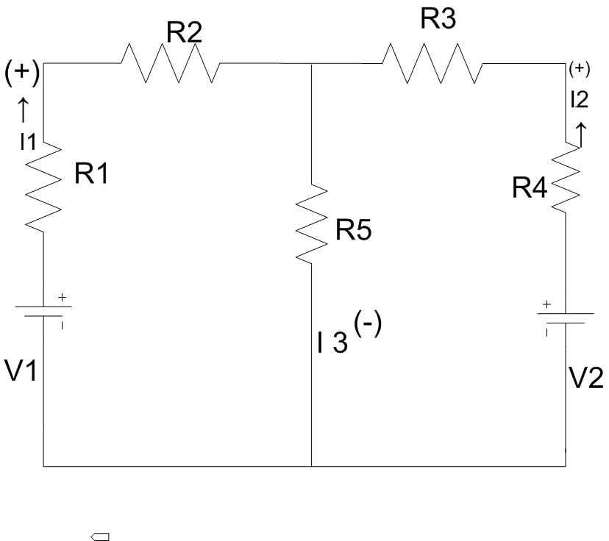

**OBSERVATION TABLE:**

**A) For Kirchhoff’s Current Law:**

|  |  |  |  |  |
| --- | --- | --- | --- | --- |
| **S.N.** | **Applied Voltage (V)** | **Current (l1)**  **mA1** | **Current( l2)**  **mA2** | **Current( l3)**  **mA3** |
| 1 | 5V | 0.78 | 1.9 | 2.68 |
| 2 | 10V | 2.1 | 2.0 | 3.9 |
| 3 | 12V | 10.9 | 0.9 | 3.7 |

**B) For Kirchhoff’s Voltage Law:**

|  |  |  |  |  |
| --- | --- | --- | --- | --- |
| **S.N.** | **Applied Voltage (V)** | **Voltage( V1)** | **Voltage (V2)** | **Voltage (V3)** |
| 1 | 5V | 4.13V | 0.40V | 0.45V |
| 2 | 8V | 7V | 0.6V | 0.39V |
| 3 | 12V | 10.9V | 0.9V | 0.2V |

**CALCULATIONS:**

1. **For Kirchhoff’s Current Law :**

Applying KCL,

I3=I1+I2

I3-I2-I1=0

Hence KCL is verified.

**2) For Kirchhoff’s Voltage Law:**

Applying KVL to closed path ABEFA.

V1+V2+V3=V

V1+V2+V3-V=0

Hence KVL is verified.

**PROCEDURE:**

1. **For Kirchhoff’s Current Law:**

1) Make circuit connections as shown in figure. A.

2) Adjust supply voltage to some suitable value. Note down the readings of milli-ammeters mA1, mA2 and mA3.

3) Record three sets of such readings by adjusting supply voltage.

4) Apply KCL and check the summation of incoming and outgoing current at node B.

**2) For Kirchhoff’s Voltage Law:**

1) Make circuit connections as shown in figure.B.

2) Adjust supply voltage to some suitable value. Note down the readings of voltmeters V, V1, V2 and V3.

3) Record three sets of such readings by adjusting supply voltage.

4) Apply KVL and check the summation of supply voltage and voltages drop in a closed loop.

**RESULT:**

1. The incoming current is found to be equal to the outgoing current
2. The total input voltage is equal to the total voltage drop in the ckt.

**CONCLUSION:**

**DISCUSSION QUESTIONS:**

1. State Kirchhoff's first (current) law (KCL).
2. State Kirchhoff's second (voltage) law (KVL).
3. [What is the internal resistance of an ideal voltage source and ideal current source?](https://www.quora.com/What-is-the-internal-resistance-of-an-ideal-voltage-source)

**REFERENCE:**

* Robert L. Boylestad, “Introductory Circuit Analysis”, Pearson (2011).
* William H. Hayt, Jack E. Kemmerly, “Problems and Solutions in Engineering Circuit Analysis 1st Edition”,TataMc-graw Hill Publishing (2012).
* D. Roy Choudhury, “Networks and Systems 2 Edition”,New Age International (2010).
* http://www.nptel.ac.in/courses/108108076/4
* https://www.youtube.com/watch?v=QYE6uZlPqZY